* Here I have used **LoggingExample.java** class. It is given below

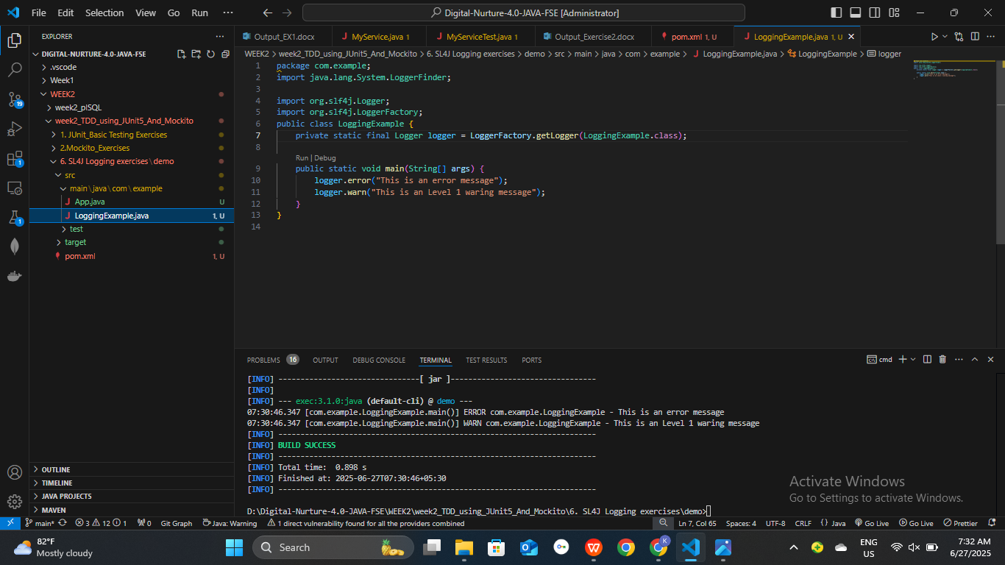

* **Dependency in pom.xml:** Both SLF4J api and logback binding for slf4j is included in the dependency.

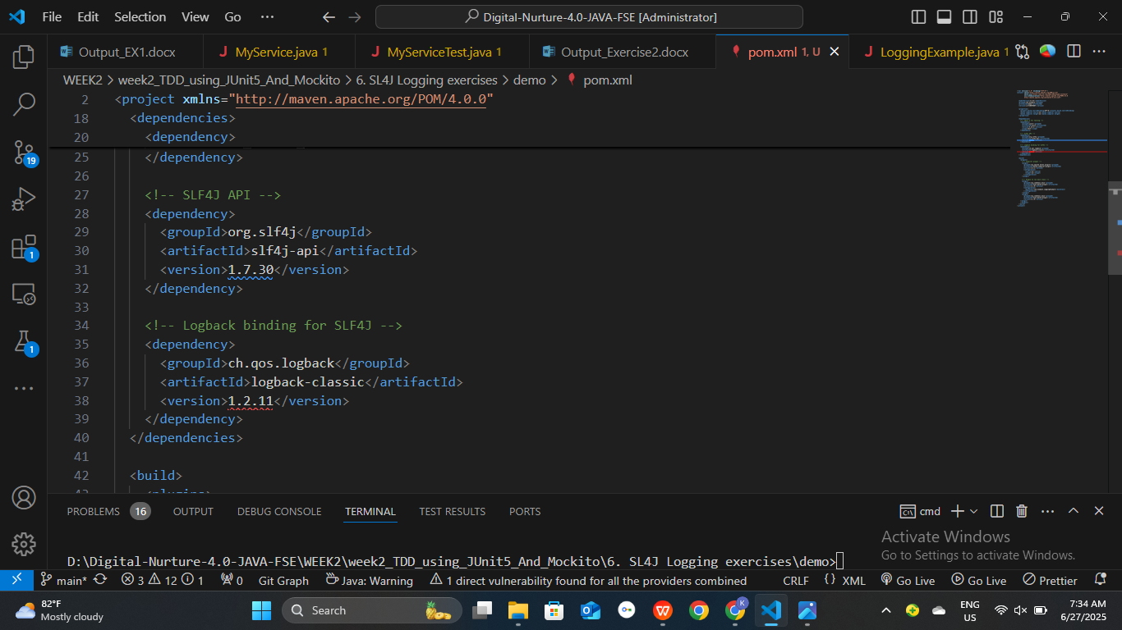

* **Terminal output** from ‘ mvn clean compile’ & then

‘mvn exec:java-Dexec.mainClass="com.example.LoggingExample"

[INFO] --- exec:3.1.0:java (default-cli) @ demo ---

07:38:07.084 [com.example.LoggingExample.main()] ERROR com.example.LoggingExample - This is an error message

07:38:07.093 [com.example.LoggingExample.main()] WARN com.example.LoggingExample - This is an Level 1 waring message

[INFO] ------------------------------------------------------------------------

[INFO] BUILD SUCCESS

* **Screen shot:**

